**New Life Organization (NELO), Youth and Environmental Vision (YEV), commemorated Universal Health Coverage day (UHC), In Mwanza.**

Youth and Environmental Vision (YEV) in partnership with New Life Organization (NELO), commemorated the Universal health coverage day (UHC), December 12, 2019 in Mwanza as to mark the progress , and level of implementation for the sustainable development goal (SDG) 3.8.

As UNDP stress, 400 million people globally have no access to health care, and 40 % lack social protection such as health insurance, while 1.6 billion people live in fragile settings where protracted crises, combined with weak national capacity to deliver basic health services, present a significant challenge to global health. Yet of this by the end of 2017, 21.7 Million people living with HIV were receiving antiretroviral therapy. Yet more than 15 Million people are still waiting for treatment. In worst situation, every 2 second someone aged 30-70 years dies prematurely from non communicable diseases, chronic respiratory diseases, diabetes or cancer. This all point for global initiatives as Tanzania is not unique from this intervention. This call for New Life and YEV to solicit fund from Global health strategies to mobilize different stakeholders in commemoration of this day to discus and plan for future intervention.

This event was sponsored by Global Health Strategies, and the Universal health coverage team where Youth and Environmental Vision spearhead planning, organizing in collaboration with New Life Organization in Tanzania. The event among other thing was able to discuss and plan how to attain this SDG goal in 2030, develop intervention that will make change to achieve this goal in collaboration with Government and various stakeholders. Although health insurance has been spurring for almost few years and particular for formal sector. The discussion has been to extend to informal sector but making health insurance affordable and through usage of technologies to reach large population.

New Life Organization and Youth and Environmental Vision (YEV), therefore are working to develop new proposal focusing in health insurance intervention and development of universal health product targeting individual or groups). More updates will be communicated in this website. For more information, if you’re interested in this program kindly contact us to our email newlife@nelo.co.tz

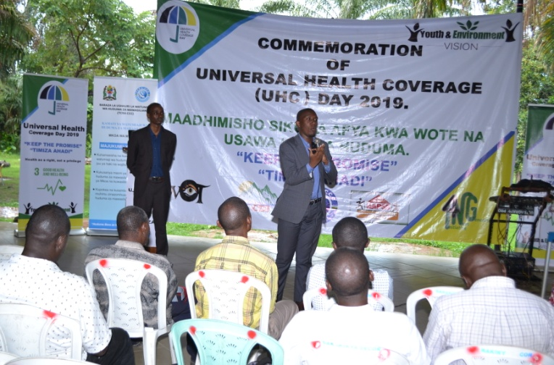

Participant sharing his opinion on the need to have universal health insurance for all people to ensure that health services are accessible to all until 2030 as stipulated in the sustainable development goal 3.8.

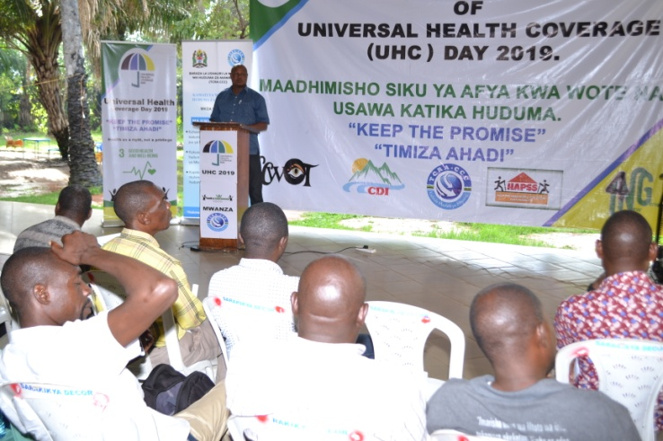

**Regional Medical Officer (R.M.O** ), Mwanza Region , Dr SILAS WAMBURA addressing the forum participants on the governemt plans towards achieving universal health coverage even before 2030 as far as SDG 3.8 is concerned.

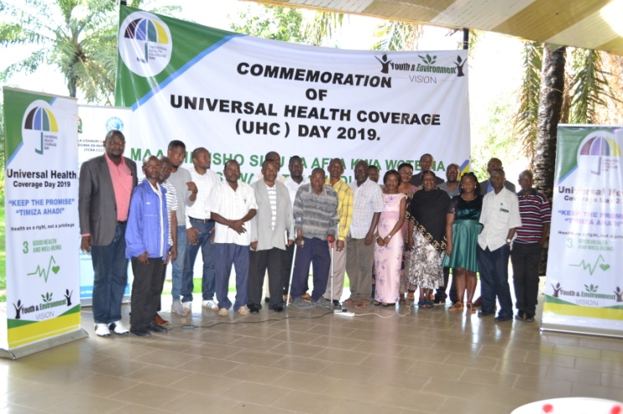

Invited CSOs and Participants pose with Youth and Environmental Vision ( YEV) and New Life Organization (NELO) for UHC 2019 event in Mwanza.